# ***Automatic Lighting - Mohamed Idris M***

## ***CIRCUIT :***

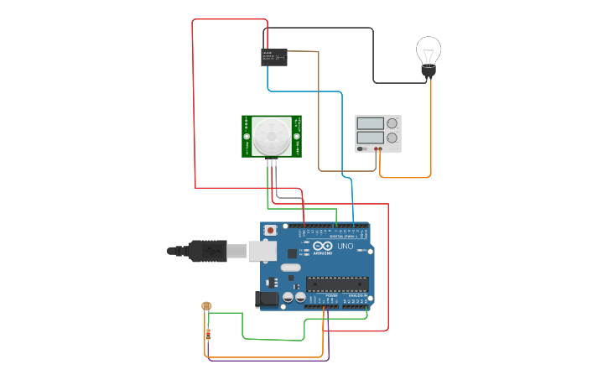

## ***COMPONENTS USED :***

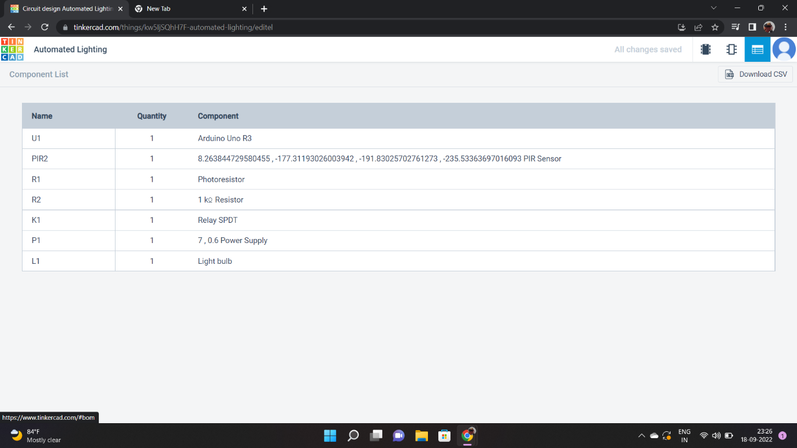

## ***PROJECT DISCRIPTION :***

*Automated lighting system detects if anyone enters in the room (range of sensor used), the light bulb will glow.The intensity of light is adjusted automatically according to the brightness level present in the room already.*

## ***CODE :***

*int PIR ,PS;*

*void setup ()*

*{*

*pinMode( 7, INPUT);*

*pinMode( 3, OUTPUT);*

*pinMode( A5, INPUT);*

*Serial.begin(9600);*

*}*

*void loop ()*

*{*

*PIR= digitalRead(7);*

*PS= analogRead(A5);*

*Serial.println(PIR);*

*Serial.println(PS);*

*if ((PIR>0) && (PS<550))*

*{*

*analogWrite(3,map(PS,549,6,0,255));*

*delay(5000);*

*}*

*else*

*digitalWrite(3, 0);*

*}*

*TINKERCAD LINK :*

*https://www.tinkercad.com/things/1EakIdgo72w*

## *DESIGNED BY :*

*MOHAMED IDRIS M*

*REG NO : 113119UG04058*

*COLLEGE : VELTECH MULTITECH COLLEGE*